**Practical No:-1**

**Q.1) Write a Program for Randomized Selection Algorithm**

from random import randrange

def partition(x, pivot_index = 0):

i = 0

if pivot_index !=0: x[0],x[pivot_index] = x[pivot_index],x[0]

for j in range(len(x)-1):

if x[j+1] < x[0]:

x[j+1],x[i+1] = x[i+1],x[j+1]

i += 1

x[0],x[i] = x[i],x[0]

return x,i

def RSelect(x,k):

if len(x) == 1:

return x[0]

else:

xpart = partition(x,randrange(len(x)))

x = xpart[0] # partitioned array

j = xpart[1] # pivot index

if j == k:

return x[j]

elif j > k:

return RSelect(x[:j],k)

else:

k = k - j - 1

return RSelect(x[(j+1):], k)

x = [3,1,8,4,7,9]

for i in range(len(x)):

print (RSelect(x,i))

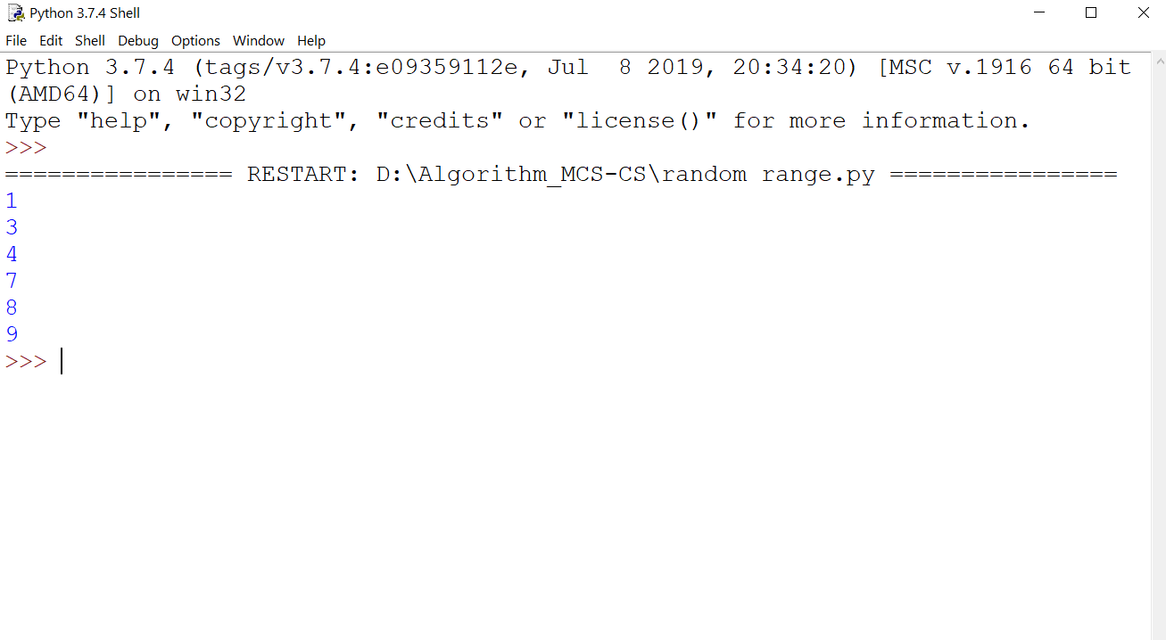

**Practical No:-2**

**Q.2) Write a Program for Heap Sort Algorithm**

##Python program for implementation of heap Sort

# To heapify subtree rooted at index i.

# n is size of heap

def heapify(arr, n, i):

largest = i # Initialize largest as root

l = 2 * i + 1 # left = 2*i + 1

r = 2 * i + 2 # right = 2*i + 2

# See if left child of root exists and is

# greater than root

if l < n and arr[i] < arr[l]:

largest = l

# See if right child of root exists and is

# greater than root

if r < n and arr[largest] < arr[r]:

largest = r

# Change root, if needed

if largest != i:

arr[i],arr[largest] = arr[largest],arr[i] # swap

# Heapify the root.

heapify(arr, n, largest)

# The main function to sort an array of given size

def heapSort(arr):

n = len(arr)

# Build a maxheap.

for i in range(n, -1, -1):

heapify(arr, n, i)

# One by one extract elements

for i in range(n-1, 0, -1):

arr[i], arr[0] = arr[0], arr[i] # swap

heapify(arr, i, 0)

# Driver code to test above

arr = [ 12, 11, 13, 5, 6, 7]

heapSort(arr)

n = len(arr)

print ("Sorted array is")

for i in range(n):

print ("%d" %arr[i]),

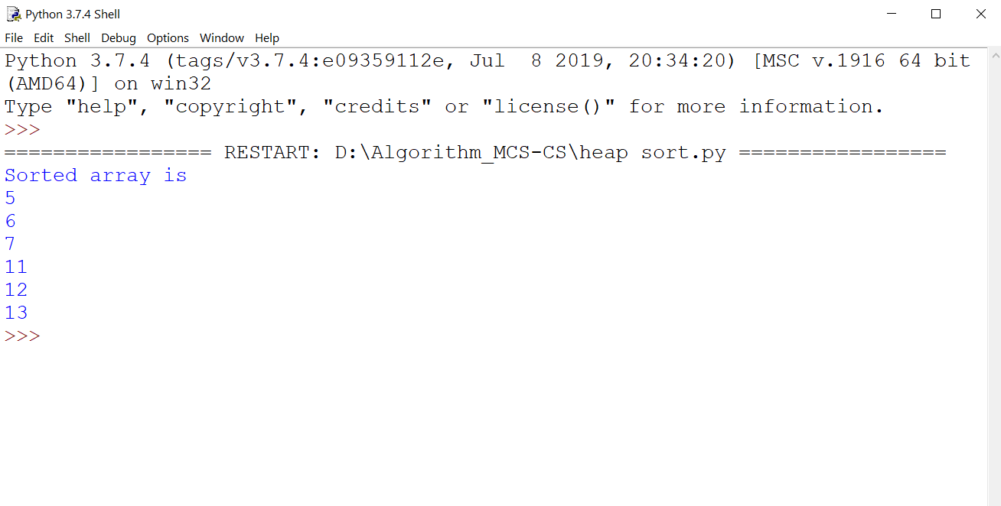

**Practical No:-3**

**3) Write a Program to perform Radix Sort Algorithm**

def countingSort(arr, exp1):

n = len(arr)

# The output array elements that will have sorted arr

output = [0] * (n)

# initialize count array as 0

count = [0] * (10)

# Store count of occurrences in count[]

for i in range(0, n):

index = (arr[i]/exp1)

count[int((index)%10)] += 1

# Change count[i] so that count[i] now contains actual

# position of this digit in output array

for i in range(1,10):

count[i] += count[i-1]

# Build the output array

i = n-1

while i>=0:

index = (arr[i]/exp1)

output[ count[ int((index)%10) ] - 1] = arr[i]

count[int((index)%10)] -= 1

i -= 1

# Copying the output array to arr[],

# so that arr now contains sorted numbers

i = 0

for i in range(0,len(arr)):

arr[i] = output[i]

# Method to do Radix Sort

def radixSort(arr):

# Find the maximum number to know number of digits

max1 = max(arr)

# Do counting sort for every digit. Note that instead

# of passing digit number, exp is passed. exp is 10^i

# where i is current digit number

exp = 1

while max1/exp > 0:

countingSort(arr,exp)

exp *= 10

# Driver code to test above

arr = [ 170, 45, 75, 90, 802, 24, 2, 66]

radixSort(arr)

for i in range(len(arr)):

print(arr[i],end=" ")

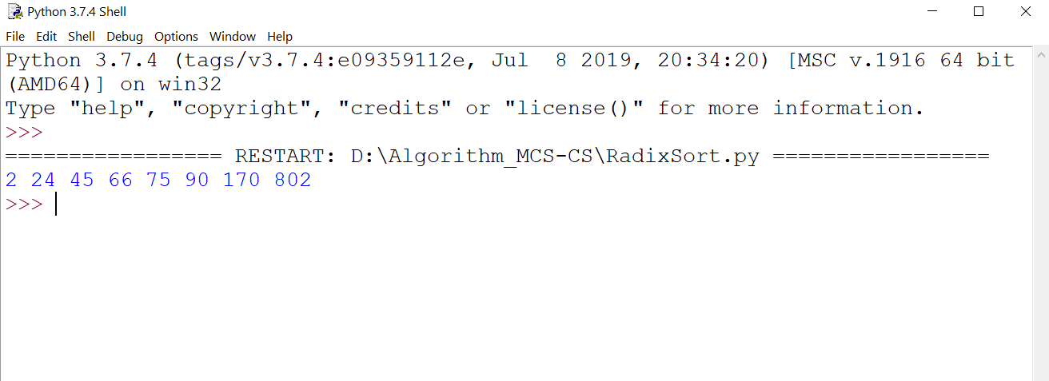

**Practical No:-4**

**4) Write a Program to Perform Bucket Sort Algorithm**

def insertionSort(b):

for i in range(1,len(b)):

up=b[i]

j=i-1

while j>=0 and b[j]>up:

b[j+1]=b[j]

j-=1

b[j+1]=up

return b

def bucketSort(x):

arr=[]

slot_num=10

for i in range(slot_num):

arr.append([])

for j in x:

index_b=int(slot_num*j)

arr[index_b].append(j)

for i in range(slot_num):

arr[i]=insertionSort(arr[i])

k=0

for i in range(slot_num):

for j in range(len(arr[i])):

x[k]=arr[i][j]

k+=1

return x

x=[0.897,0.565,0.656,0.1234,0.665,0.3434]

print("Sorted array is:")

print(bucketSort(x))

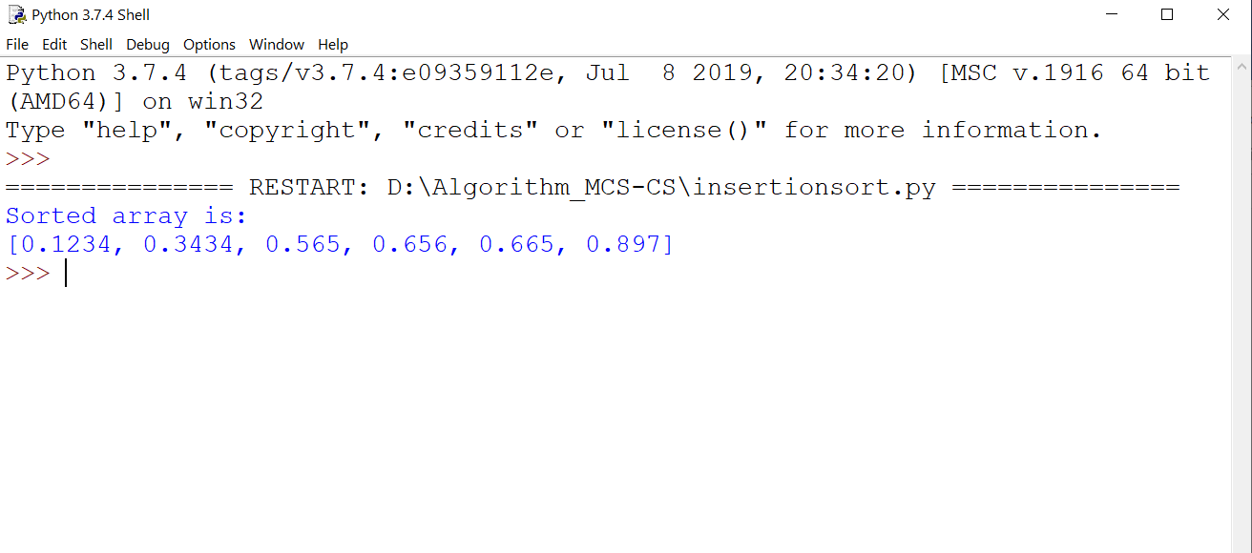

**Practical No:-5**

**5) Write a Program to Perform Folyd-Warshall algorithm**

V = 4

INF=99999

def floydWarshall(graph):

dist = list(map(lambda i :list( map(lambda j : j , i)) ,graph))

for k in range(V):

for i in range(V):

for j in range(V):

dist[i][j] = min(dist[i][j] ,dist[i][k]+ dist[k][j])

printSolution(dist)

def printSolution(dist):

for i in range(V):

for j in range(V):

if(dist[i][j] == INF):

print('%7s' %("INF"),)

else:

print('%7d\t' %(dist[i][j]),)

if j == V-1:

print(" ")

graph = [[0,5,INF,10],

[INF,0,3,INF],

[INF,INF,0,1],

[INF,INF,INF,0]

]

floydWarshall(graph);

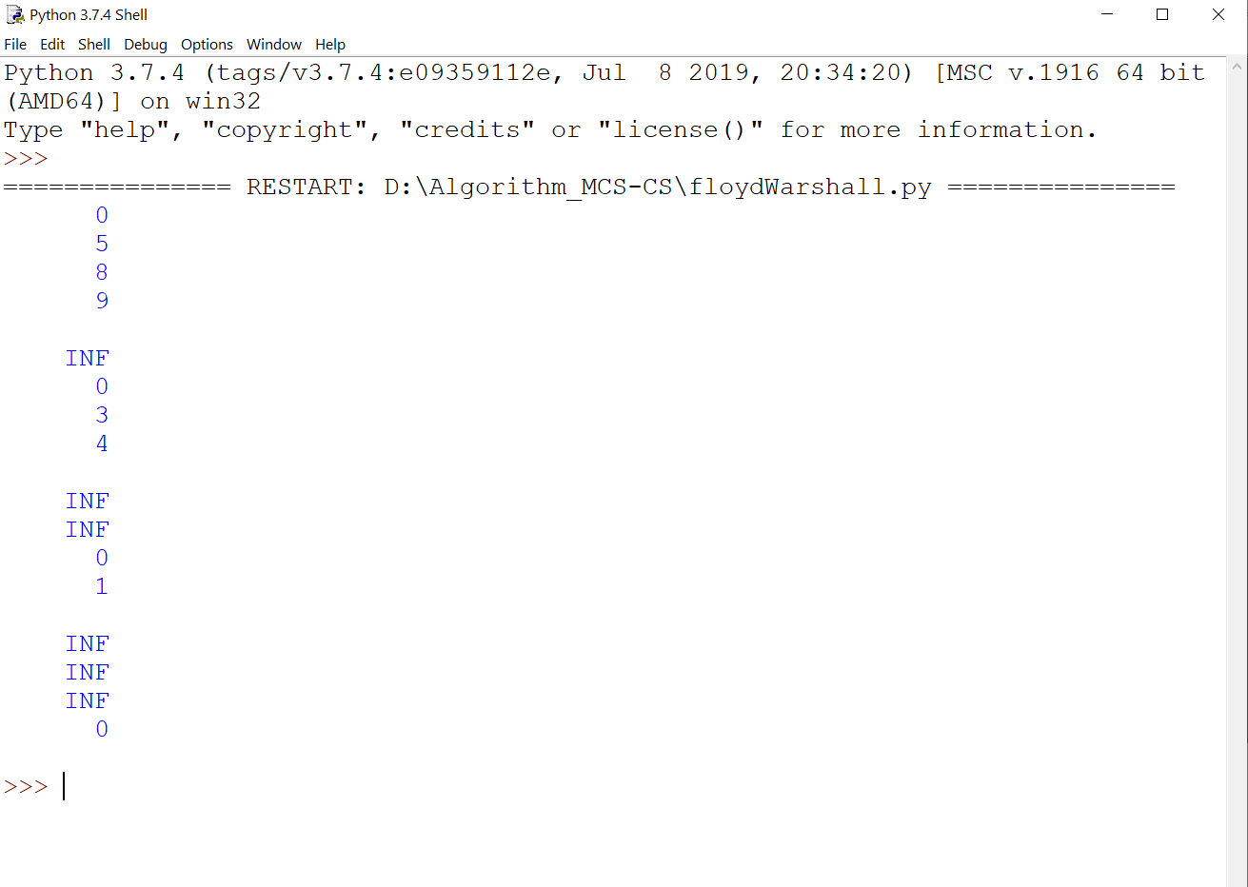

**Practical No:-6**

**6) Write a Program for Counting Sort Algorithm in python**

def countSort(arr):

# The output character array that will have sorted arr

output = [0 for i in range(len(arr))]

# Create a count array to store count of individual

# characters and initialize count array as 0

count = [0 for i in range(256)]

# For storing the resulting answer since the

# string is immutable

ans = ["" for _ in arr]

# Store count of each character

for i in arr:

count[ord(i)] += 1

# Change count[i] so that count[i] now contains actual

# position of this character in output array

for i in range(256):

count[i] += count[i-1]

# Build the output character array

for i in range(len(arr)):

output[count[ord(arr[i])]-1] = arr[i]

count[ord(arr[i])] -= 1

# Copy the output array to arr, so that arr now

# contains sorted characters

for i in range(len(arr)):

ans[i] = output[i]

return ans

# Driver code

if __name__ == '__main__':

arr = "geeksforgeeks"

ans = countSort(arr)

print("Sorted character array is % s" % ("".join(ans)))

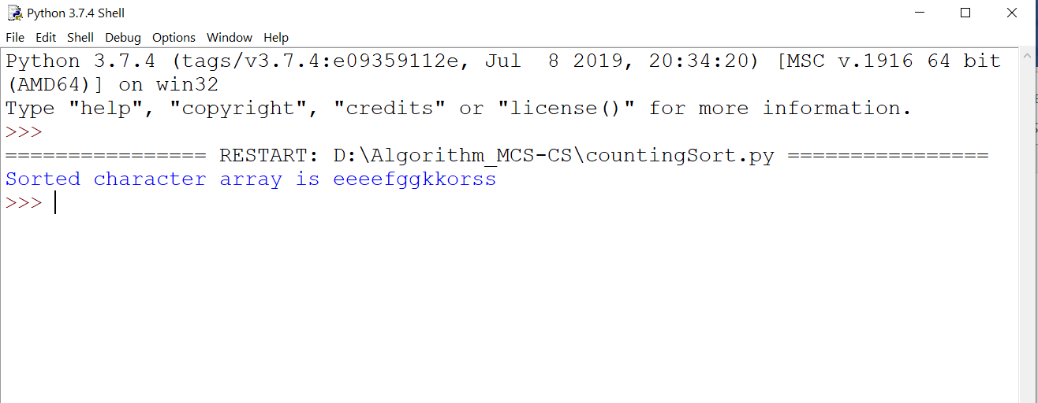

**Practical No:-7**

**7) Write a program for Set Covering Problem**

def set_cover(universe,subsets):

"""Find a family of subsets that covers the universal set"""

elements=set(e for s in subsets for e in s)

#check the subsets cover the universe

if elements !=universe:

return None

covered=set()

cover=[]

#greedily add the subsets with the most uncovered points

while covered !=elements:

subset=max(subsets,key=lambda s: len(s-covered))

cover.append(subset)

covered |=subset

return cover

def main():

universe=set(range(1,11))

print(universe)

subsets=[set([1,2,3,8,9,10]),

set([1,2,3,4,5]),

set([4,5,7]),

set([5,6,7]),

set([6,7,8,9,10])]

cover=set_cover(universe,subsets)

print(cover)

if __name__=='__main__':

main()

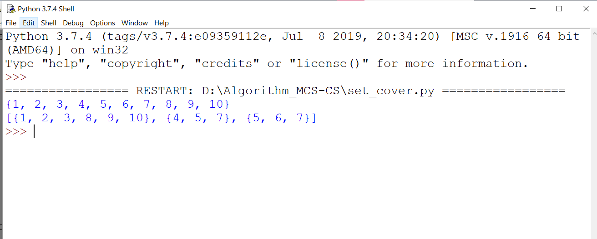

**Practical No:-8**

**8) Write a Program for found a subset with given sum**

def isSubsetSum(set,n,sum):

if(sum==0):

return True

if(n==0 and sum!=0):

return False

if(set[n-1]>sum):

return isSubsetSum(set,n-1,sum);

return isSubsetSum(set,n-1,sum) or isSubsetSum(set,n-1,sum-set[n-1])

set=[3,34,4,12,5,2]

sum=9

n=len(set)

if(isSubsetSum(set,n,sum)==True):

print("Found a subset with given sum")

else:

print("No subset with given sum")

